Certificate

This is to certify that “Prashul Vaishnav” of “St. Anne’s Sr. Sec. School” of class XII-A has successfully completed his computer science project on “Question Paper Generator” under the guidance of “Mrs. Archana Aggarwal.” He has taken proper care and shown at most sincerity in completion of this project. I certify that the project is up to my expectation and as proper guidelines issued by C.B.S.E.

Archana Aggarwal
PGT Computer Science External Examiner
Teacher

Acknowledgement

- I would like to express my special thanks to my teacher “Mrs. Archana Aggarwal” who gave me the golden opportunity to do this wonderful project of Computer Science on “Generating Question Paper” and also helped me in completing my project. I came to know so many things from her.
- Secondly I would like to thank my partner “Siddharth Mehrotra” for supporting me in completing this project in the limited time frame. I would also like to thank my parents who supported me in finalizing my project.

Introduction

This project “Question Paper Generator” is developed in C++, which is one of the object oriented languages that could be the most powerful link to future programming methodologies. One of the main reasons behind the success of C++ is that it supports object oriented technology i.e. it uses real life concepts for its programming.
This project aims at computerization of the manual system of making a question paper. There are numerous advantages of this system like reliability, efficiency etc. This project helps us in saving the previous time.Error while handling the system can also be minimized.
The other feature of this question paper generator is that the files are strongly safe, easily accessible when needed, data addition, deletion and modification.
Apart from this we have also added a “Library Management System '' in which you can choose books from different genres like fiction, biographies etc. and read their reviews, issue them etc.

Abstract

Facing a problem while making a question paper is very common with all the teachers, may be of any subject and any class teacher. So the main objective the question paper generator is to ease the work of all the teachers.
In the question paper generator all the teachers have the facility to change the questions in the question bank by accessing the data files by using the user id and password given to them. Teachers can generate the question paper by simply entering the class, subject and maximum marks.
They can also add different questions belonging to different categories of marking schemes like 1 mark questions,2 mark questions,3 mark questions and 5 mark questions, as soon as the maximum mark limit is reached a notification will be displayed that maximum marks have been reached.
This way instead of finding the questions, then writing them and then printing the paper is reduced to just two two steps: enter the details and print the paper.
Managing the library manually is a very tedious task, you have to maintain the records of various books ,who has issued which book and for what period of time, with the library management software you can easily check what all books are available in which genre.
So this is how you can get an idea about the exact book which you want to read by reading its reviews, also you can write your own reviews about the book which you have already read.

Functions

Hardware and software

Hardware Requirements:-

- Minimum 64 MB RAM (128 MB desirable) at server.
- Minimum 60 MB of free disk space for files.
- A CD ROM drive.
- Minimum of 48 MB of RAM at workstation.

Software Requirements:-

- Borland Turbo C++ compiler
- Windows 98 or above.

How to Use

This project is user friendly, it is completely menu driven with no complex input requirements. At each stage a menu has been designed with a number of options, according to need or previous inputs, to choose from.
Accordingly it asks for desired input or it displays its features, we can move to the selected tasks by the entering the respective choice.

Menu Design
Introduction-

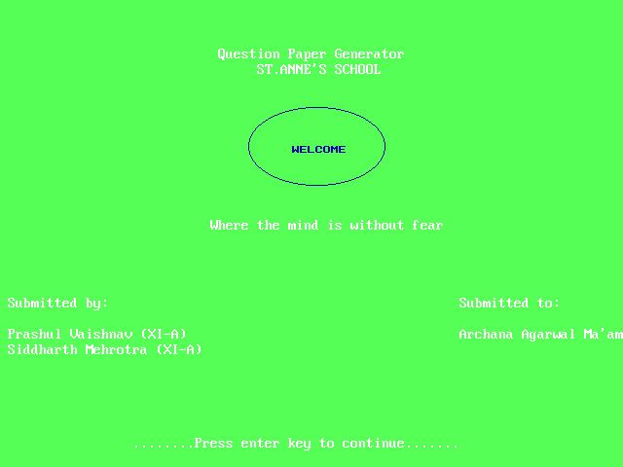

Main menu-

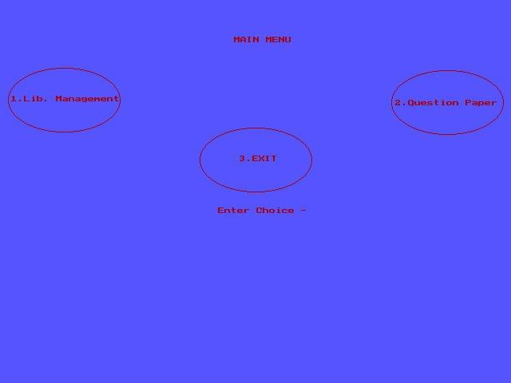

Sub menu(for question paper)-

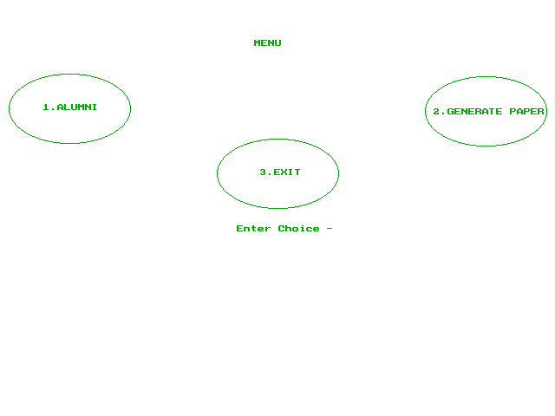

Option 2(generate paper)-

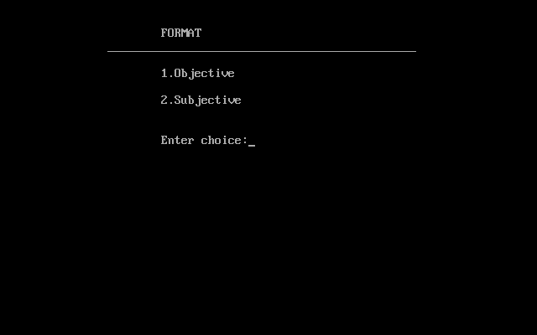

Entering the details-
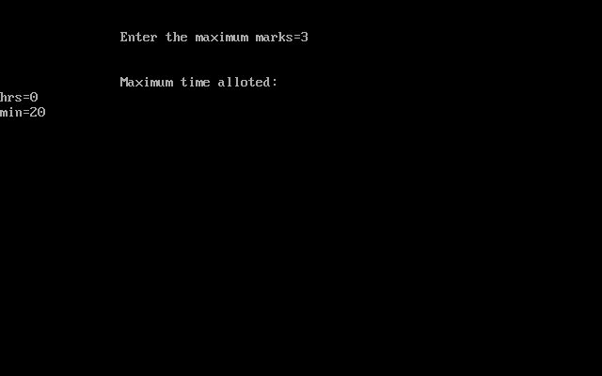
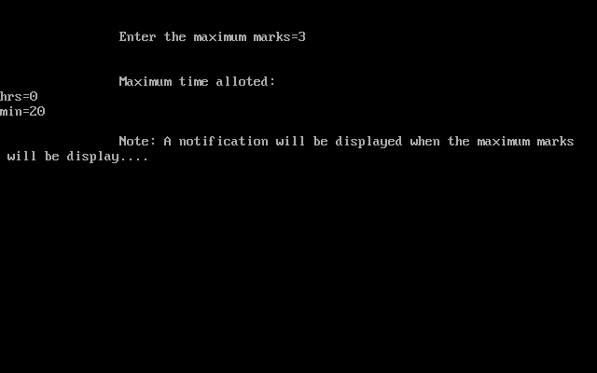
Questions being added-
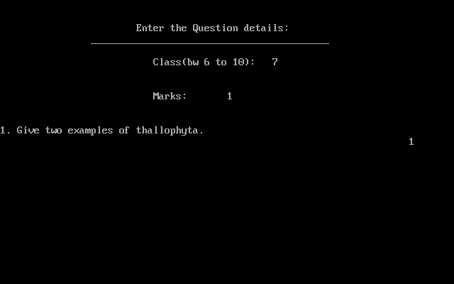
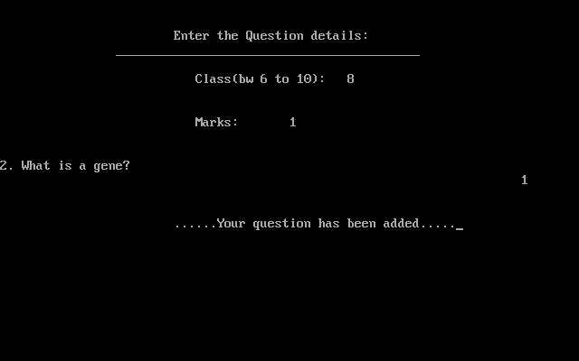
Notification for max . marks -
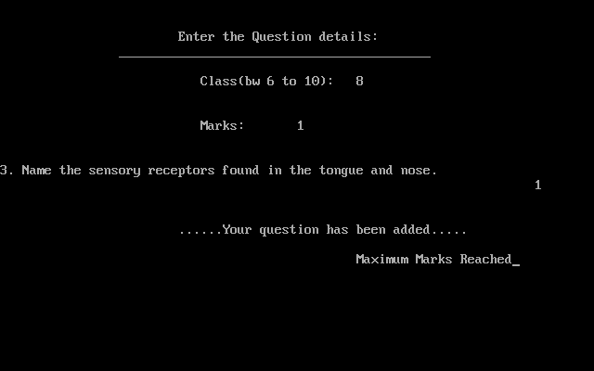

Printing the paper-
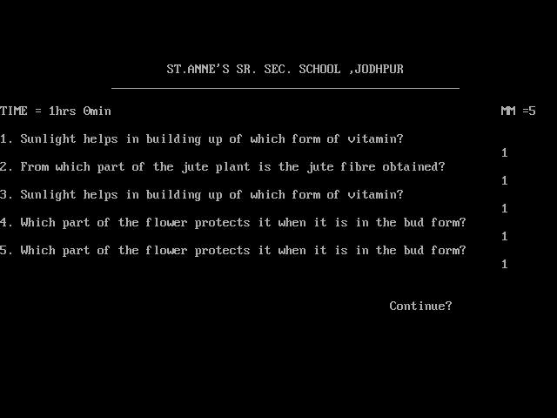
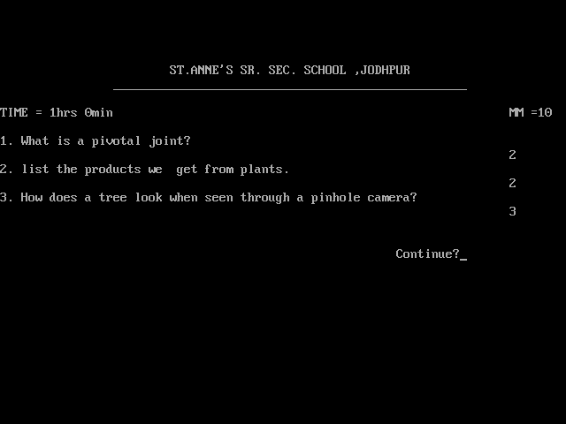

Option 1(Alumni)-
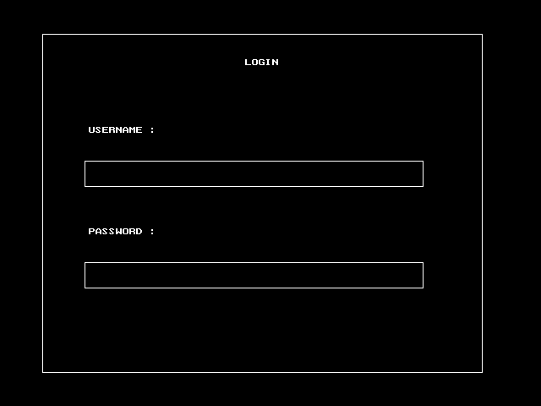

Login page-
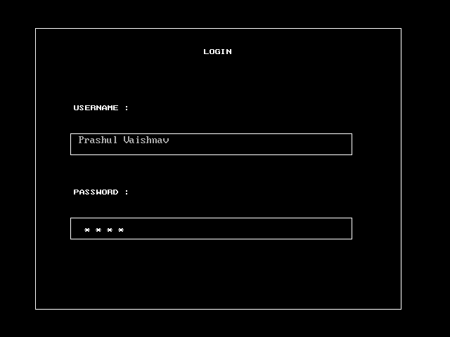
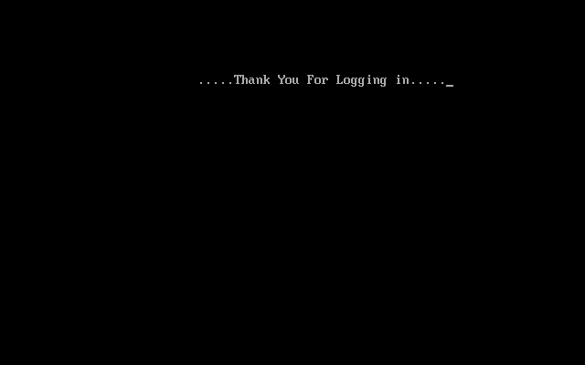
Adding the question-
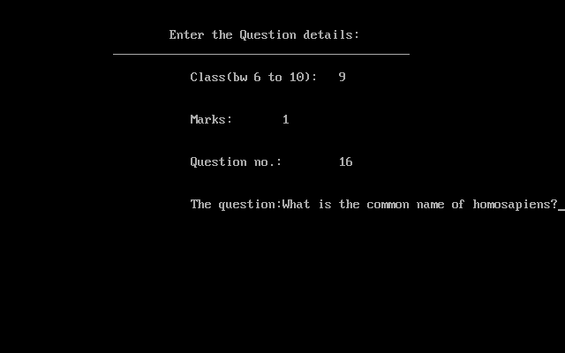
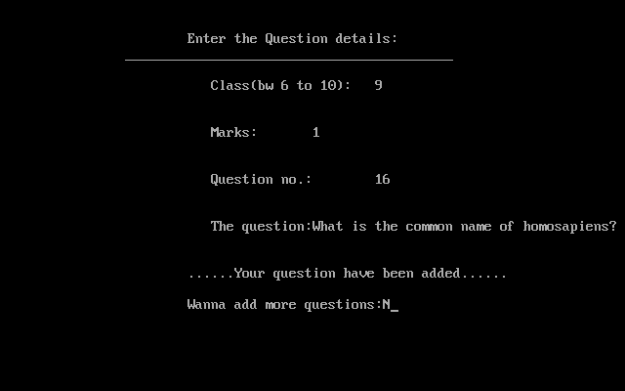
Library-
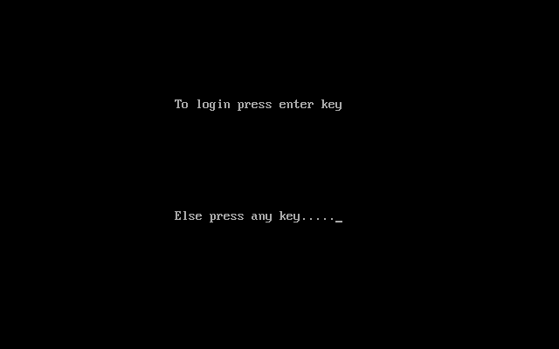
Login page-
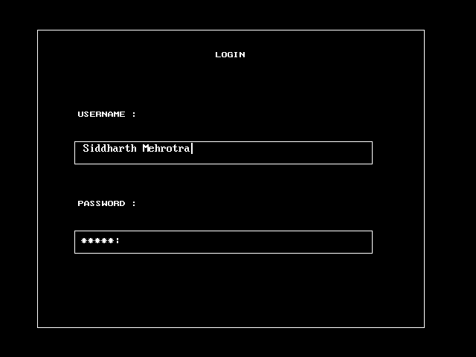

Sub menu (for library)-
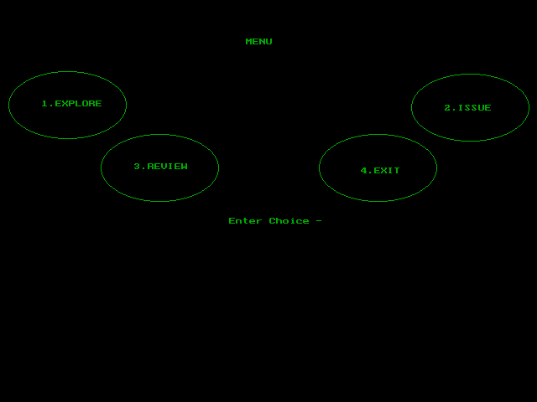

Option 1-
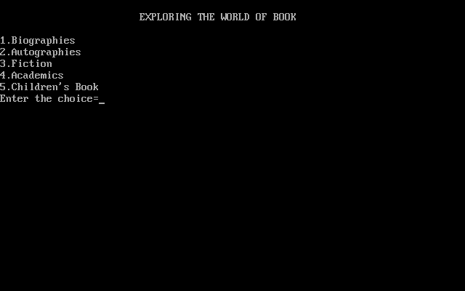
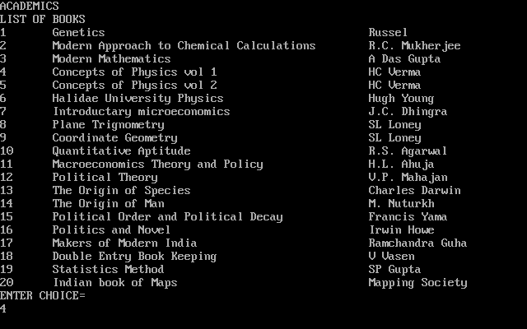
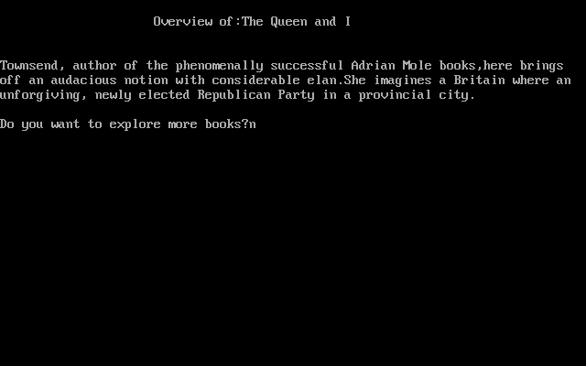

Option 2-
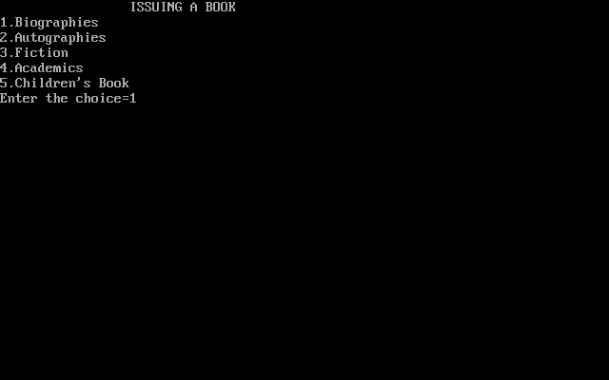
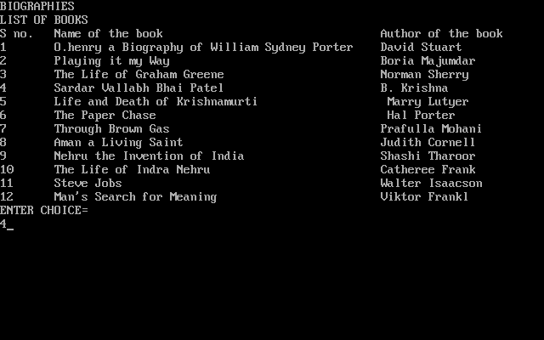
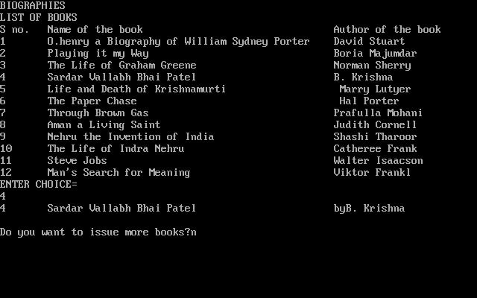

Option 3-
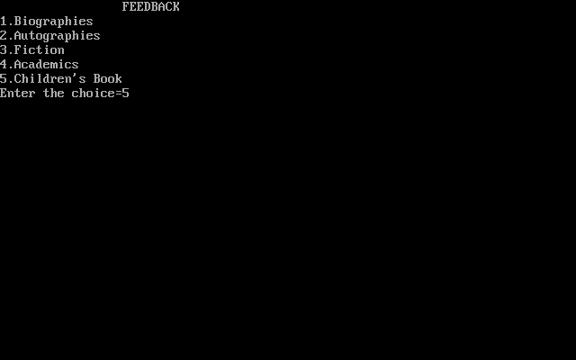
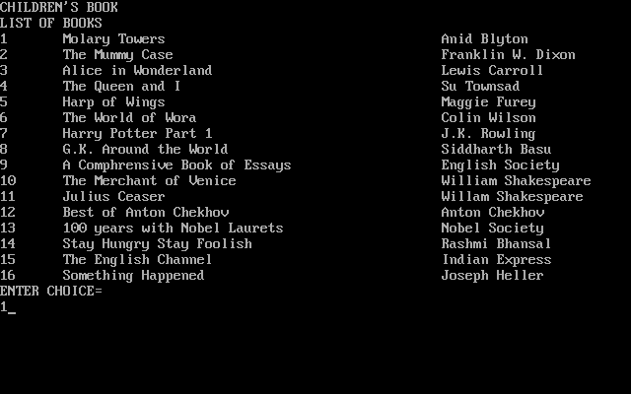
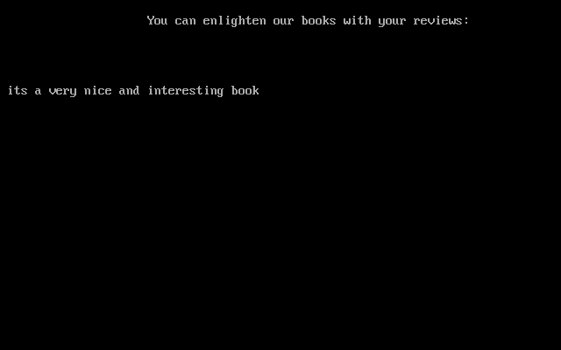
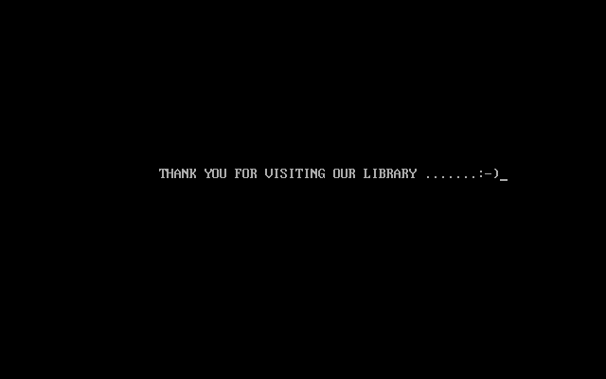

Source Code
#include<final.h>
#include<stdlib.h>
#include<stdio.h>
#include<process.h>
#include<conio.h>
#include<graphics.h>
#include<string.h>
#include<fstream.h>
int mm,n=1;
struct time
{int hrs,min;
}t;

class question
{int clas,marks,qno;
char que[150];
public:
question()
{clas=marks=qno=0;
strcpy(que,"Null");
}
~question()
{cout<<" ";}
void enter()
{cout<<"\n\n\t\t\tEnter the Question details:\n\t\t__________________________________________";
cout<<"\n\n\t\t\t Class(b\w 6 to 10):\t";
cin>>clas;
cout<<"\n\n\t\t\t Marks:\t";
cin>>marks;
cout<<"\n\n\t\t\t Question no.:\t";
cin>>qno;
cout<<"\n\n\t\t\t The question:";
gets(que);
}
void enter1()
{cout<<"\n\n\t\t\tEnter the Question details:\n\t\t__________________________________________";
cout<<"\n\n\t\t\t Class(b\w 6 to 10):\t";
cin>>clas;
cout<<"\n\n\t\t\t Marks:\t";
cin>>marks;
qno=random(16);
}
void disp()
{cout<<n++<<". "<<que<<"\n\t\t\t\t\t\t\t\t\t"<<marks<<"\n";
}
int getmark()
{return marks;
}
int check(question q1);
};
int question::check(question q1)
{if((marks==q1.marks) && (clas==q1.clas) && (qno==q1.qno))
return 1;
else
return 0;
}

void add()
{question q;
ofstream fout;
fout.open("master.dat",ios::app|ios::binary);
if(!fout)
cout<<"Error";
else
{char cho;
do{clrscr();
q.enter();
fout.write((char*)&q,sizeof(q));
fout<<"\n";
cout<<"\n\n\t\t\t......Your question have been added......";
cout<<"\n\n\t\t\tWanna add more questions:";
cin>>cho;
}while(cho=='y'||cho=='Y');
}
fout.close();
}

void qdisp()
{clrscr();
question q;
n=1;
char ch;
ifstream fin;
fin.open("qpaper.dat",ios::binary);
if(!fin)
cout<<"\n\n\t\t\t\t\tError";
else
{cout<<"\n\n\t\t\tST.ANNE'S SR. SEC. SCHOOL ,JODHPUR\n\t\t__________________________________________________\n";
cout<<"\nTIME = ";
if(t.hrs!=0)
cout<<t.hrs<<"hrs ";
cout<<t.min<<"min"<<"\t\t\t\t\t\t\tMM ="<<mm<<"\n\n";
fin.seekg(0);
while(fin.read((char*)&q,sizeof(q)))
{
fin.get(ch);
q.disp();
}
}
fin.close();
}

void call(char ch)
{randomize();
question q,q1;
ifstream fin;
ofstream fout;
fout.open("qpaper.dat",ios::binary);
if(ch=='o')
fin.open("mastero.dat",ios::binary);
else if(ch=='s')
fin.open("masters.dat",ios::binary);
if(!fin||!fout)
cout<<"\n\n\t\t\tError";
else
{clrscr();
cout<<"\n\n\t\tEnter the maximum marks=";
cin>>mm;
cout<<"\n\n\t\tMaximum time alloted:\nhrs=";
cin>>t.hrs;
cout<<"min=";
cin>>t.min;
int ch,p,flag=0,c=0;
char cho;

cout<<"\n\t\tNote: A notification will be displayed when the maximum marks\n will be display....";
getch();
do{clrscr();
q.enter1();
c+=q.getmark();
fin.seekg(0);
while(fin.read((char*)&q1,sizeof(q1)))

{
q1.disp();
getch();
if(q.check(q1))
{
fout.write((char*)&q1,sizeof(q1));
fout<<"\n";
cout<<"\n\n";
q1.disp();
getch();
cout<<"\n\n\t\t\t......Your question has been added.....";
getch();
flag=1;
break;
}
}
if(flag==0)
{cout<<"not found";
getch();
}
}while(c<mm);
if(c==mm)
cout<<"\n\n\t\t\t\t\t\tMaximum Marks Reached";
getch();
}
fin.close();
fout.close();
qdisp();
}

void quegen()
{int ch;
char cho;
do{clrscr();
n=1;
cout<<"\n\n\t\t\tFORMAT\n\t\t\______________________________________________\n\n\t\t\t1.Objective\n\n\t\t\t2.Subjective\n\n\n\t\t\tEnter choice:";
cin>>ch;
cout<<"\n\n\t\t_____________________________________________" ;
switch(ch)
{case 1:call('o');
break;
case 2:call('s');
break;
default:cout<<"\n\n\t\t\t\t\t\tInvalid choice";
}
cout<<"\n\n\t\t\t\t\t\t\tContinue?";
cin>>cho;
}while(cho=='y'||cho=='Y');
}

void glog()
{/* request auto detection */
int gdriver = DETECT, gmode, errorcode;
int l1,t1,r1,b1,l2,t2,r2,b2,l3,t3,r3,b3,x1=290,y1=70,x2=105,y2=150,x3=105,y3=270;
/* initialize graphics and local variables */
initgraph(&gdriver, &gmode, "g:\\bgi");

outtextxy(x1,y1,"LOGIN");
outtextxy(x2,y2,"USERNAME :");
outtextxy(x3,y3,"PASSWORD :");

l1=50; l2=500; l3=500;
t1=40; t2=190; t3=310;
r1=570; r2=100; r3=100;
b1=440; b2=220; b3=340;

/* draw a rectangle */
rectangle(l1,t1,r1,b1);
rectangle(l2,t2,r2,b2);
rectangle(l3,t3,r3,b3);
}

int enterpass()
{int pa=0;
char ch;
do{
ch=getche();
if(ch!=13)
{cout<<"*";
pa = pa*10 + (ch-48);
}
}while(ch!=13);
return pa;
}

void passo()
{char user[80];
long int pass;
gotoxy(15,13);
gets(user);
gotoxy(15,21);
pass=enterpass();
if( !(strcmp(user,"Prashul Vaishnav")) || !(strcmp(user,"Siddharth Mehrotra")))
{if(pass==3132)
{cleardevice();
closegraph();
clrscr();
gotoxy(28,6);
cprintf(".....Thank You For Logging in.....");
getch();
clrscr();
add();
}
else
{cleardevice();
closegraph();
cout<<"\n\n\t\t\t\t\t\tInvalid password";
}
}
else
cout<<"\n\n\t\t\t\t\t\tInvalid username";
}

void login()
{clrscr();
int flag=0;
do{
flag++;
gotoxy(28,6);
cprintf("\n\n\t\t\t\tThis is case sensitive program......");
glog();
passo();
}while(flag==3);

/*clean up */
cleardevice();
closegraph();
clrscr();
}

void front_pg()
{/* select a driver and mode that supports */
/* multiple background colors. */
int gdriver=DETECT, gmode, errorcode;
int bkcol;

/* initialize graphics and local variables */
initgraph(&gdriver, &gmode, "g:\\bgi");

{
/* clear the screen */
cleardevice();

/* select a new background color */
setbkcolor(10);

/* output a messsage */
if (bkcol == WHITE)
setcolor(EGA_BLUE);
// getch();

}
int a1=300,b1=150;

int midx=325,midy=150;
int stangle = 0, endangle = 360;
int xradius = 70, yradius =40 ;
setcolor(1);
ellipse(midx,midy,stangle,endangle,xradius,yradius);
/* output text starting at the C.P. */
outtextxy(a1,b1,"WELCOME");

gotoxy(29,4);
printf("Question Paper Generator\n");
gotoxy(34,5);
printf("ST.ANNE'S SCHOOL");
gotoxy(28,15);
printf("Where the mind is without fear\n");
gotoxy(2,20);
printf("Submitted by:\n");
gotoxy(60,20);
printf("Submitted to:\n");
gotoxy(2,22);
printf("Prashul Vaishnav (XI-A)\n");
gotoxy(60,22);
printf("Archana Agarwal Ma'am");
gotoxy(2,23);
printf("Siddharth Mehrotra (XI-A)\n");
gotoxy(2,24);
cout<<"\n\n\n\n\n\t\t ........Press enter key to continue.......";
getch();
cleardevice();
closegraph();

}

int menu()
{//cleardevice();

int gdriver=DETECT, gmode, errorcode;
int bkcol;

/* initialize graphics and local variables */
initgraph(&gdriver, &gmode, "g:\\bgi");

{
/* clear the screen */
cleardevice();

/* select a new background color */
setbkcolor(15);

/* output a messsage */
if (bkcol == WHITE)
setcolor(EGA_BLUE);

}
int a1=293,b1=46,a2=50,b2=120,a3=500,b3=125,a4=300,b4=195,c=265,d=260;

int midx2=80,midy2=125,midx3=560,midy3=128,midx4=320,midy4=200;
int stangle = 0, endangle = 360;
int xradius = 70, yradius =40 ;
int c1;
setcolor(2);
ellipse(midx2,midy2,stangle,endangle,xradius,yradius);
ellipse(midx3,midy3,stangle,endangle,xradius,yradius);
ellipse(midx4,midy4,stangle,endangle,xradius,yradius);

/* output text starting at the C.P. */
outtextxy(a1,b1,"MENU");
outtextxy(a2,b2,"1.ALUMNI");
outtextxy(a3,b3,"2.GENERATE PAPER");
outtextxy(a4,b4,"3.EXIT");
outtextxy(c,d," Enter Choice - ");
cin>>c1;
cleardevice();
closegraph();
return c1;
}

int mainmenu()
{//cleardevice();

int gdriver=DETECT, gmode, errorcode;
int bkcol;

/* initialize graphics and local variables */
initgraph(&gdriver, &gmode, "g:\\bgi");

{
/* clear the screen */
cleardevice();

/* select a new background color */
setbkcolor(9);

/* output a messsage */
if (bkcol == WHITE)
setcolor(EGA_BLUE);

}
int a1=293,b1=46,a2=14,b2=120,a3=495,b3=125,a4=300,b4=195,c=265,d=260;

int midx2=80,midy2=125,midx3=560,midy3=128,midx4=320,midy4=200;
int stangle = 0, endangle = 360;
int xradius = 70, yradius =40 ;
int c1;
setcolor(4);
ellipse(midx2,midy2,stangle,endangle,xradius,yradius);
ellipse(midx3,midy3,stangle,endangle,xradius,yradius);
ellipse(midx4,midy4,stangle,endangle,xradius,yradius);

/* output text starting at the C.P. */
outtextxy(a1,b1,"MAIN MENU");
outtextxy(a2,b2,"1.Lib. Management");
outtextxy(a3,b3,"2.Question Paper");
outtextxy(a4,b4,"3.EXIT");
outtextxy(c,d," Enter Choice - ");
cin>>c1;
cleardevice();
closegraph();
return c1;
}

void main()
{clrscr();
front_pg();
char cho;
do{
clrscr();
int ch;
ch=mainmenu();
switch(ch)
{case 1:cl();
break;
case 2:do{clrscr();
int ch;
ch=menu();
switch(ch)
{case 1:login();
break;
case 2:quegen();
break;
case 3:exit(0);
default:cout<<"\n\n\n\t\t\t\t\t\tInvalid choice";
}
clrscr();
gotoxy(26,13);
cout<<"\n\n\t\t\t\tDo you want to visit the menu\n";
cin>>cho;
}while(cho=='y' || cho=='Y');
clrscr();
gotoxy(22,12);
cprintf("..........THANK YOU.......:-)");
break;
default:cout<<"\n\nInvalid choice";
}
clrscr();
gotoxy(26,13);
cout<<"\n\n\t\t\t\tDo you want to visit the Main menu\n";
cin>>cho;
}while(cho=='y' || cho=='Y');
remove("masters.dat");
getch();
}

Data Dictionary
Limitations and Enhancement
In the question bank ,from which the the code is extracting data, is not generating the question no. automatically.

Bibliography

- Sumita Arora C++ Class 11 Part 1
- Sumita Arora C++ Class 12 Part 2

